E-Project Developer Guide
Fitness Tracker

Group Members

- Muhammad Shaheer
ID: Student1401788

- Waqas
ID: Student1368218

- Syed Uzair Hashmi
ID: Student1385544

- Ikramullah
ID: Student1351046

- Muhammad Jamal
ID: Student1340552

Faculty Members

Teacher: Miss Neha Shah
Coordinator: Miss Fiza Arif

INTRODUCTION
The thirst for learning, upgrading technical skills and applying the concepts in
real life environment at a fast pace is what the industry demands from IT
professionals today. However busy work schedules, far-flung locations,
unavailability of convenient time-slots pose as major barriers when it comes to
applying the concepts into realism. And hence the need to look out for
alternative means of implementation in the form of laddered approach.
The above truly pose as constraints especially for our students too! With their
busy schedules, it is indeed difficult for our students to keep up with the genuine
and constant need for integrated application which can be seen live especially so
in the field of IT education where technology can change on the spur of a
moment. Well, technology does come to our rescue at such times!!
Keeping the above in mind and in tune with our constant endeavour to use
Technology in our training model, we at Aptech have thought of revolutionizing
the way our students learn and implement the concepts using tools themselves
by providing a live and synchronous eProject learning environment!
So what is this eProject?
eProject is a step by step learning environment that closely simulates the
classroom and Lab based learning environment into actual implementation. It is a
project implementation at your fingertips!! An electronic, live juncture on the
machine that allows you to
• Practice step by step i.e. laddered approach.
• Build a larger more robust application.
• Usage of certain utilities in applications designed by user.
• Single program to unified code leading to a complete application.
• Learn implementation of concepts in a phased manner.
• Enhance skills and add value.
• Work on real life projects.
• Give a real life scenario and help to create applications more
complicated and useful.
• Mentoring through email support.
The students at the centre are expected to complete this eProject and send
complete documentation with source code to eProjects Team
Looking forward to a positive response from your end!!

Screenshots

Login Form code :
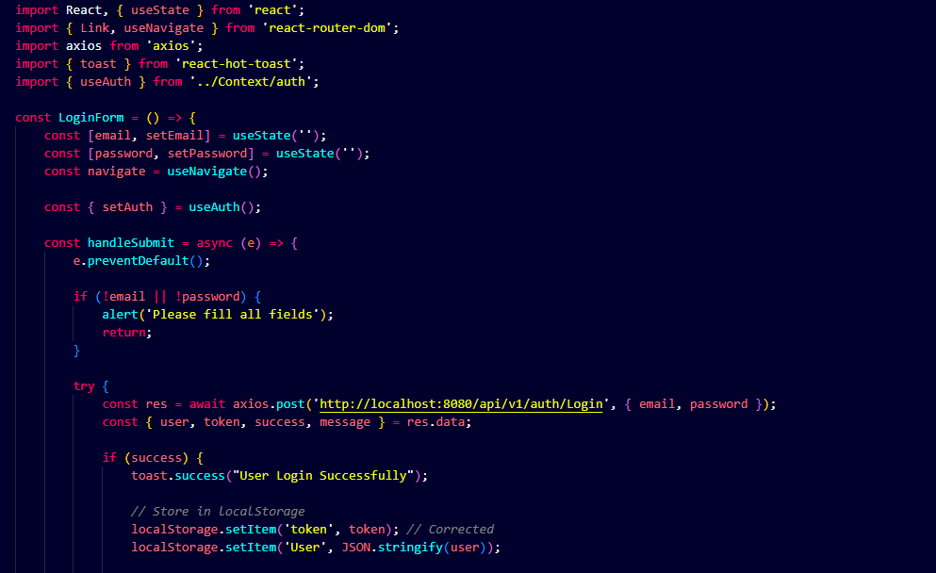

Sign up code:

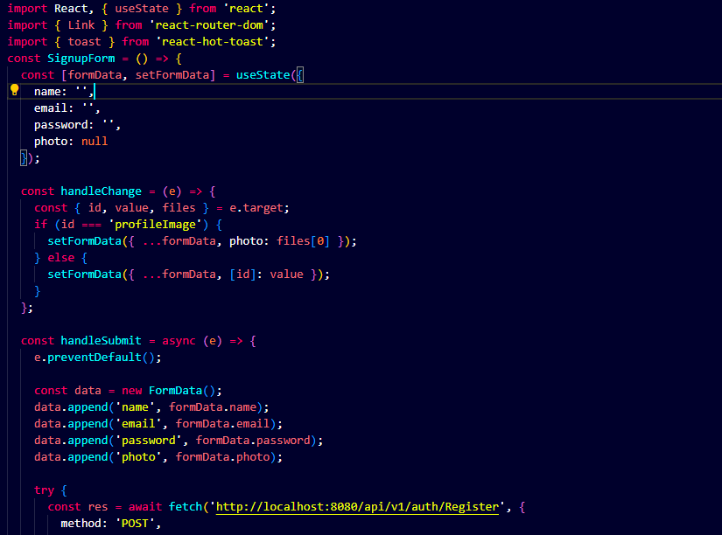

Main Dashboard code:

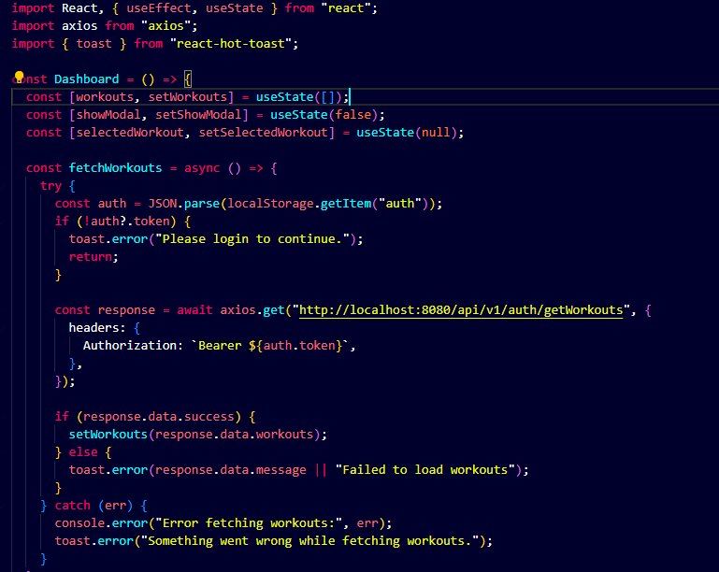

Profile Code:

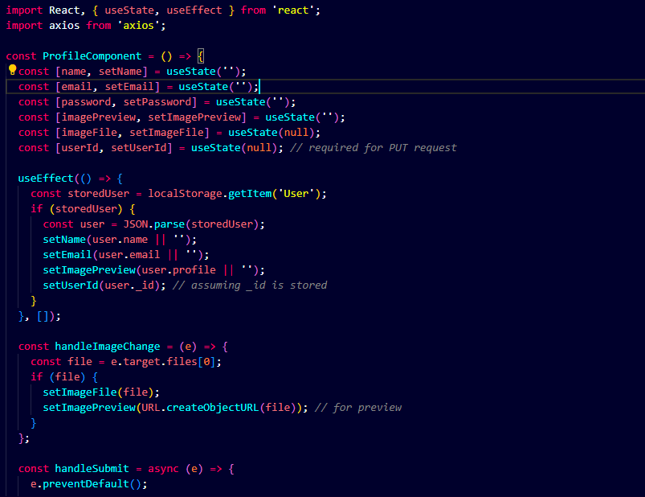

Thank You

